28.28: a) From Eq. (29-17), 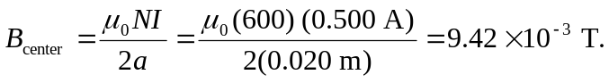
b) From Eq. (29-16),

